Asia-China-Coin-Spade Flat Handle-Pointed Foot not in H

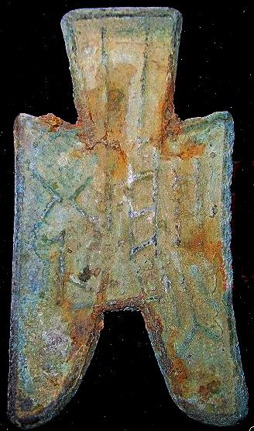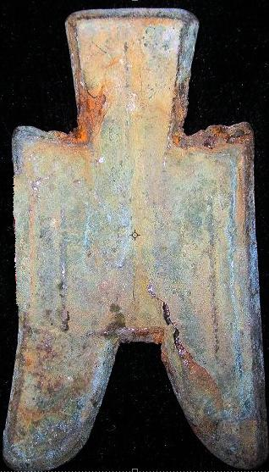

length 5.2cm. / 2.05 in., width 2.9cm. / 1.14 in.

Order details Printer friendly page

Sold by

[bcculture](http://myworld.ebay.com/bcculture) ( [81](http://feedback.ebay.com/ws/eBayISAPI.dll?ViewFeedback&userid=bcculture)  )

+ Show additional actions

Delivery package 1 of 1

Estimated delivery Friday, Jan 17, 2014 - Friday, Feb 14, 2014

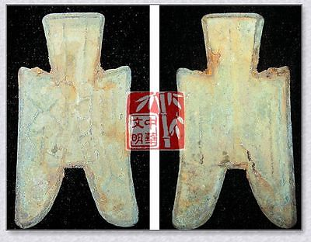

[WarringStatesPeriod ZHAO CITY MINT CURRENCY 1/2MONEY BRONZE SPADESHAPE COIN蔺半尖足布](http://www.ebay.com/itm/251409411918)

Item price

$10.49

Quantity

1

Item number

251409411918

Shipping service

Economy Shipping from outside US

[Leave feedback](http://feedback.ebay.com/ws/eBayISAPI.dll?LeaveFeedbackShow&useridfrom=802-867&useridto=bcculture&item=251409411918&transactid=0) [Contact seller](http://contact.ebay.com/ws/eBayISAPI.dll?FindAnswers&frm=3998&iid=251409411918&redirect=0&requested=bcculture) [Return item](http://return.ebay.com/ws/eBayISAPI.dll?ResolveReturn&eventName=viewSelectedItem&TransactionId=0&ItemId=251409411918)

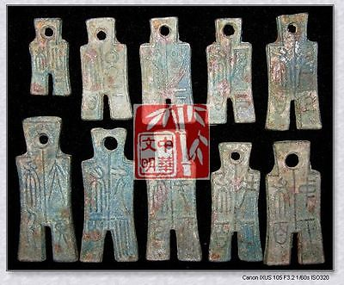

[VINTAGE CHINA HAN KINGDOM XINMANG TIME MINT SET MONEY BRONZE SCAPE COIN新莽十布RARE](http://www.ebay.com/itm/251412560569)

Item price

$79.99

Quantity

1

Item number

251412560569

Shipping service

Economy Shipping from outside US

[Leave feedback](http://feedback.ebay.com/ws/eBayISAPI.dll?LeaveFeedbackShow&useridfrom=802-867&useridto=bcculture&item=251412560569&transactid=1360710721015) [Contact seller](http://contact.ebay.com/ws/eBayISAPI.dll?FindAnswers&frm=3998&iid=251412560569&redirect=0&requested=bcculture) [Return item](http://return.ebay.com/ws/eBayISAPI.dll?ResolveReturn&eventName=viewSelectedItem&TransactionId=1360710721015&ItemId=251412560569)

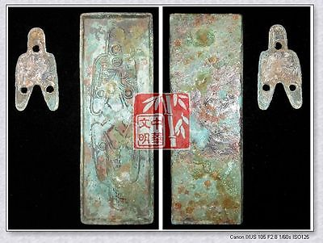

[WARRINGSTATESPERIOD ZHAO NATION MINT MONEY MODEL BRONZE SPADE-COIN PATTERN下匕阝阳一两](http://www.ebay.com/itm/251413215696)

Item price

$69.99

Quantity

1

Item number

251413215696

Shipping service

Economy Shipping from outside US

[Leave feedback](http://feedback.ebay.com/ws/eBayISAPI.dll?LeaveFeedbackShow&useridfrom=802-867&useridto=bcculture&item=251413215696&transactid=1360711405015) [Contact seller](http://contact.ebay.com/ws/eBayISAPI.dll?FindAnswers&frm=3998&iid=251413215696&redirect=0&requested=bcculture) [Return item](http://return.ebay.com/ws/eBayISAPI.dll?ResolveReturn&eventName=viewSelectedItem&TransactionId=1360711405015&ItemId=251413215696)

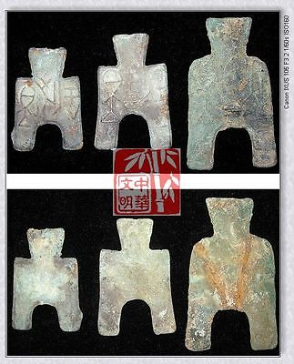

[VINTAGEWarringStatesPeriod WEI CITY MINT CURRENCY MONEY BRONZE SPADE COIN圁阳*釿SET](http://www.ebay.com/itm/251413392937)

Item price

$99.99

Quantity

1

Item number

251413392937

Shipping service

Economy Shipping from outside US

[Leave feedback](http://feedback.ebay.com/ws/eBayISAPI.dll?LeaveFeedbackShow&useridfrom=802-867&useridto=bcculture&item=251413392937&transactid=1360711797015) [Contact seller](http://contact.ebay.com/ws/eBayISAPI.dll?FindAnswers&frm=3998&iid=251413392937&redirect=0&requested=bcculture) [Return item](http://return.ebay.com/ws/eBayISAPI.dll?ResolveReturn&eventName=viewSelectedItem&TransactionId=1360711797015&ItemId=251413392937)

### Shipping address

Ralph J Coffman Jr  
149 Atlantic Ave   
Swampscott MA 01907-2427  
United States

Phone number  
781 584 7091

### Order total

Subtotal $260.46

Shipping $100.00

Shipping discount -$9.00

#### Total

## $351.46

[View PayPal transaction](http://payments.ebay.com/ws1/eBayISAPI.dll?IntermediateResolutionInfo&itemid=0&transId=0&pn=UnifiedCheckoutSummaryRedirect2PP&qs=itemid%3D0%26transId%3D0%26buyerorseller%3D0%26)

### Order information

Order placed on  
Monday, Dec 30, 2013

Having a problem with this purchase?  
[Resolve problem](http://res.ebay.com/ws/eBayISAPI.dll?ResolutionCenter)

Payment method   
PayPal

Payment date  
Monday, Dec 30, 2013